BIG DATA AND BUSINESS INTELLIGENCE

CIS4008 – N

**DATA GLOBAL SUPPLY CHAINN PERFORMANNCE ANALYSIS**

NAME: OLASUPO OLUWAFEMI GRACE

STUDENT ID: C2343369

11TH JANUARY 2023

Table of Contents

Executive Summary 5

Key Findings 5

Recommendation 6

Introduction 8

Data Source and Description 8

Data Description 8

BI Requirements\Questions 11

Finding based on analysis and evaluation 12

Summary 19

Recommendation 20

Conclusion 20

ICA – Appendix: BI Design 21

Data Pre-Processing or Data Cleansing 21

BI Data Modelling 28

DAX and M Language 30

Dashboard 33

Home Page/ Overview 33

Sales Analysis Dashboard 33

Profit Analysis Dashboard 34

Customer Analysis Dashboard 34

Shipping Analysis Dashboard 35

Predictive Analysis Dashboard 36

Reference 38

**Business Report**

# Executive Summary

The overall business process of providing products and services is critical to any organization's success. In a competitive supply chain business sector, it is important to conduct performance analysis on a regular basis. This project aims at conducting a comprehensive study of the business, with a focus on sales, profit customers, and shipping performance, in order to enable relevant stakeholders, make sound decisions based on the insights gained and increase the income and growth of the business.

## Key Findings

Based on the study of the supplied data. The following discovery was made.

* Over 36million pounds has been earned as revenue by Data Global, with an average sales value of 203 pounds. A total of 65750 orders have also been made.
* The store has made a profit of 3.97million pounds, which translates to about 10.78% in profit margin and a declining yearly growth rate
* The store has its largest market in Europe with over 10million pounds and it has its smallest market in Africa.
* Western Europe and Central America are the top performing regions
* The store has customer base of over 20000, with its largest customer base in the United States.
* 55% of orders were delivered late while 45% were delivered on time. With Western Europe and Central America having more of the late deliveries.



**Figure 1: Key performance indicators on sales analysis**



**Figure 2: Key performance indicators on profit analysis**



**Figure 3: Key performance indicators on customer analysis**



**Figure 4: Key performance indicators on customer analysis**

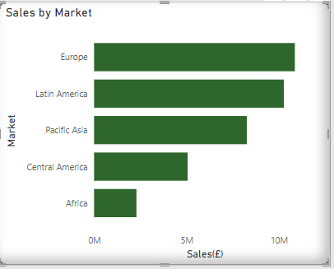

**Figure 5: Sales of top performing regions**

## Recommendation

**Pricing:** There is need to review the prices of product offered for sale, the analysis revealed that some products are being offered at a price lower than the actual cost of the product. This has been resulting into loss of revenue for the store  
**Discount:** A removal of discount from some products that are currently not profitable is being recommended as it contribute to the revenue loss experienced by the store.  
**Market Expansion:** A more aggressive campaign should be targeted at the less performing markets such as Africa and Central America, this will boost the sales of the store.  
**Effective delivery system:** The analysis shows the store has 55% late delivery ratio and this implies that many customers would have bad customer experience because of late delivery. A more effective delivery system should be implemented to enhance better customer experience.  
**Customer Penetration:** The current customer base is currently low, well-tailored marketing campaigns should be developed to increase the customer base which will likely result into more sales for the store.

# Introduction

The supply chain refers to the entire process of manufacturing and distributing a product to its intended consumers. It includes everything from the manufacturing process to the product itself, to the sale of the product, and finally to the logistics that get it to the customers or final consumer.

To achieve the best results, this process must be rigorously managed and analysed. This project aims to analyse data on the performance of the business based on Sales and Profit, as well as the shipment of the final product to the end user or customer, to identify key findings that better optimises the business's growth in the future.

## Data Source and Description

The dataset used in the analysis of this BI project is DataCo Smart Supply Chain for Big Data Analysis and was gotten from Kaggle: <https://www.kaggle.com/datasets/shashwatwork/dataco-smart-supply-chain-for-big-data-analysis>

### Data Description

|  |  |  |
| --- | --- | --- |
| **S/N** | **NAME OF COLUMN** | **DESCRIPTION** |
| 1 | Type | The type of transaction made in purchasing the products. |
| 2 | Days for shipping (real) | Actual shipping days of the purchased product |
| 3 | Days for shipping (scheduled) | Days of scheduled delivery of the purchased product |
| 4 | Benefit per order | Earnings on the order placed |
| 5 | Sales per customer | Total sales per customer made |
| 6 | Delivery Status | The delivery status of the orders made |
| 7 | Late_delivery_risk | Categorical variable that indicates if sending is late (1), it is not late (0). |
| 8 | Category Id | The product category code |
| 9 | Category Name | Description of the product category |
| 10 | Customer City | Country where the customer made the purchase |
| 11 | Customer Email | Customer's email |
| 12 | Customer Country | Country where the customer made the purchase |
| 13 | Customer Fname | Customer name |
| 14 | Customer Lname | Customer lastname |
| 15 | Customer Id | Customer ID |
| 16 | Customer Password | Masked customer key |
| 17 | Customer Segment | Types of Customers: Consumer, Corporate, Home Office |
| 18 | Customer State | State to which the store where the purchase is registered belongs |
| 19 | Customer Street | Street to which the store where the purchase is registered belongs |
| 20 | Customer Zipcode | Customer Zipcode |
| 21 | Department Id | Department code of store |
| 22 | Department Name | Department name of store |
| 23 | Latitude | Latitude corresponding to location of store |
| 24 | Longitude | Longitude corresponding to location of store |
| 25 | Market | Market to where the order is delivered : Africa , Europe , LATAM , Pacific Asia , USCA |
| 26 | Order City | Destination city of the order |
| 27 | Order Country | Destination country of the order |
| 28 | Order Customer Id | Customer order code |
| 29 | order date (DateOrders) | Date on which the order is made |
| 30 | Order Id | Order code |
| 31 | Order Item Cardprod Id | Product code generated through the RFID reader |
| 32 | Order Item Discount | Order item discount value |
| 33 | Order Item Discount Rate | Order item discount percentage |
| 34 | Order Item Id | Order item code |
| 35 | Order Item Product Price | Price of products without discount |
| 36 | Order Item Profit Ratio | Order Item Profit Ratio |
| 37 | Order Item Quantity | Number of products per order |
| 38 | Sales | Value in sales |
| 39 | Order Item Total | Total amount per order |
| 40 | Order Profit Per Order | Order Profit Per Order |
| 41 | Order Region | : Region of the world where the order is delivered: Southeast Asia, South Asia, Oceania, Eastern Asia, West Asia, West of USA , US Center , West Africa, Central Africa ,North Africa ,Western Europe ,Northern , Caribbean , South America ,East Africa ,Southern Europe , East of USA ,Canada ,Southern Africa , Central Asia , Europe , Central America, Eastern Europe , South of USA |
| 42 | Order State | State of the region where the order is delivered |
| 43 | Order Status | Order Status: COMPLETE, PENDING, CLOSED, PENDING_PAYMENT, CANCELED, PROCESSING ,SUSPECTED_FRAUD ,ON_HOLD ,PAYMENT_REVIEW |
| 44 | Product Card Id | Product code |
| 45 | Product Category Id | Product category code |
| 46 | Product Description | Product Description |
| 47 | Product Image | Link of visit and purchase of the product |
| 48 | Product Name | Product Name |
| 49 | Product Price | Product Price |
| 50 | Product Status | Status of the product stock: If it is 1 not available, 0 the product is available |
| 51 | Shipping date (DateOrders) | Exact date and time of shipment |
| 52 | Shipping Mode | The Shipping mode used by customers: Standard Class, First Class, Second Class, Same Day |

**Figure 6: Dataset with description**

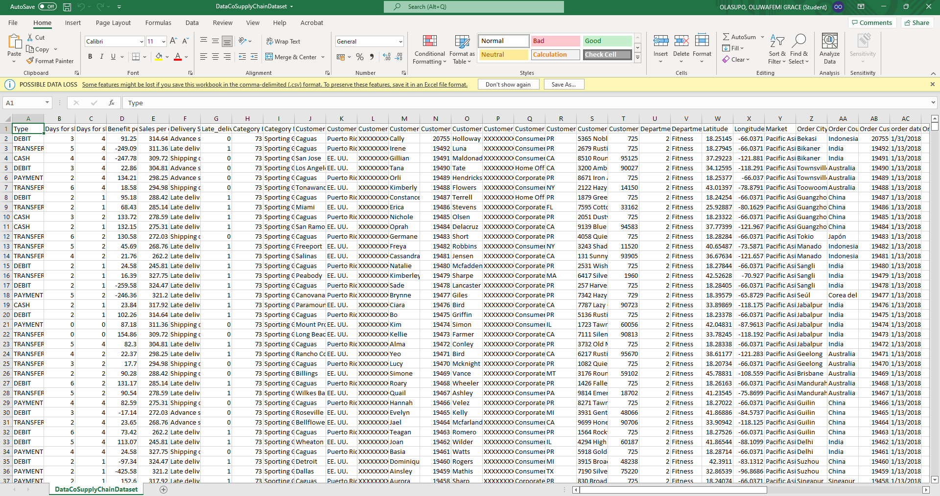

**Figure 7: Dataset values on Excel sheet**

## BI Requirements\Questions

This Bi project intends to analyse the overall performance of the Business focusing majorly on the sales, profit, customer, and shipping performances. The key performance indicators measure the overview performance of the store based on total sales, average sales, the net profit earned by the store, the annual profit growth rate. The KPI also gauges the performance based on growth in number of customers, the number of orders, and the delivery risk of the store.

SALES ANALYSIS

* What are the store’s total sales, average sales, and total order?
* What is the store’s top performing market and region?
* What is the store’s top performing products?
* What is the store’s yearly sales trend and customer’s sales forecast?

PROFIT ANALYSIS

* What are the store’s percentage profit margin, Net profit, yearly growth rate, and ratio of profit to sales?
* What is the store’ profitability across departments, and products?

CUSTOMER ANALYSIS

* What are the store’s total customers, the orders being processed and completed orders?
* How many customers does the store have from the top profitable countries?
* What is the status of order made by customers?

SHIPPING ANALYSIS

* What is the store’s delivery risk ratio and the top performing departments based on the delivery risk?
* Which regions are experiencing late deliveries?
* What is the store’s delivering status?

This solution is designed to provide the senior managers of the business with the required information needed to make business decisions in various department begin analysed.

## Finding based on analysis and evaluation

**SALES ANALYSIS**

1. **What are the store’s total sales, average sales, and total order?**

The store made a total of 36.78 million pounds in sales, with an average sale of 203.77 thousand pounds, from a total of 65.75 thousand orders. These key indicators show how the store is doing in general over time. The card visual were used to show this finding because they are the best way to measure numerical performance quickly. It helps the senior managers see the most important metrics that will help them make decisions without having to dig through the dashboard.

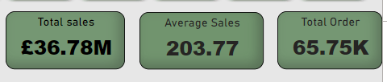

**Figure 8: Total sales/Average sales/ Total order of the store**

1. **What is the store’s top performing market and region?**

Europe is the best performing market with a sale of over 10.87 million pounds, closely followed by Latin America with a sale of 10.27 million pounds. This chart shows Africa as the least performing market with the sale of 2.29 million.

Western Europe is the region with the highest sales with 5.89 million pounds, while Central America generates about 200 thousand less of the top performing region sale amount. Southern Europe has the lowest sale of 2.05 million in comparison with the other regions.

The bubble chart is used in visualising this data due to its ability to show the relationship between numeric data using proportions.

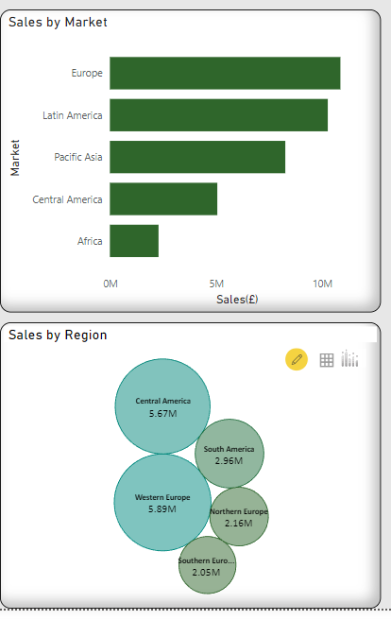

**Figure 9: Sales of top performing regions**

1. **What is the store’s top performing products?**

Field & stream is the most sold product in terms of sale with about 6.9 million pounds, while perfect fitness and Diamond Women’s serene products generated over 4million in sales.

The purpose of the graph is to show the comparison of sales amount across different products. A bar-chart was selected as it presents relational information between different groups.

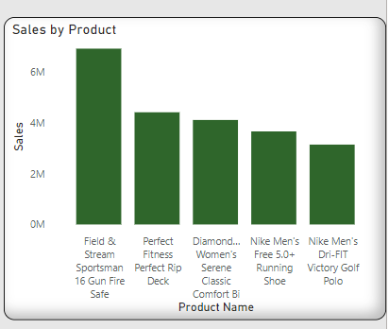

**Figure 10: Sales of top performing products**

1. **What is the store’s yearly sales trend and customer’s sales forecast?**

This shows the daily sales trend of the store with the highest sales recorded on the 26th of October 2018. The chart also displays the projected daily sales forecast for a period of one year.

A line chart was selected to track changes with the sales value over the years.

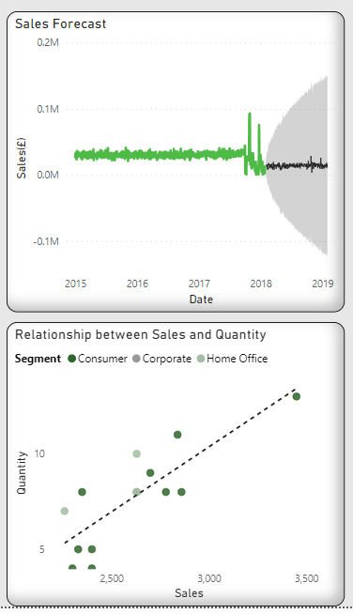

**Figure 11: Yearly Sales trend and customer sales forecast**

**PROFIT ANALYSIS**

1. **What are the store’s percentage profit margin, net profit, yearly growth rate, and ratio of profit to sales?**

The store has a net profit of 3.97 million on sales made with 10.78%.

Profit margin but with a continuous decline in the profit growth rate over the years. This analysis has been visualised using the card visual

The card was selected as the suitable visual because it provides a summarised overview of the store’s profitability. It provides the senior management with the concise position of the business and aids better decision making.

A gauge chart shows progress towards a particular goal. It displays the ratio of profit to the total sales.

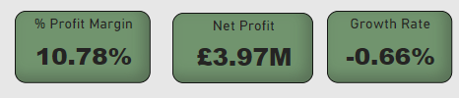

**Figure 12: Profit Margin/Net profit/Growth rate**

1. **What is the store’ profitability across departments and products?**

The Fan shop department is the most profitable department, it has earned the store about 1.8m pounds as profit, while Apparel has generated about 800k pound as profit.

The analysis of the products offered by the store shows that the SOLE E35 Elliptical is the least performing product, it posted a loss of 965 pounds, followed by Bushnell Pro with a loss of 255 pounds. Illana Erickson and Karly Jones, Ivana Walters, Gillian Benson and Yeo Espinoza all purchased products that earn the store the highest profit margin of 50%

A 100% stacked bar-chart was chosen to display the percentage of the whole by comparing the percentage of each profit margin for the top customers to the net profit

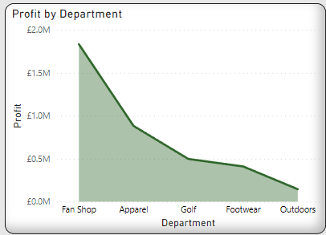

**Figure 13: Profit based on various departments**

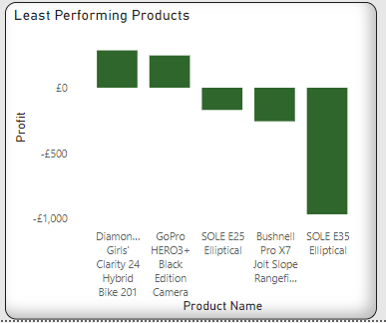

**Figure 14: The least performing products in the store**

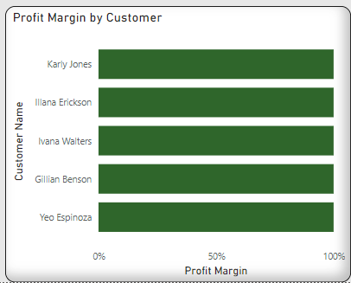

**Figure 15: Profit margin based on customers purchase**

**CUSTOMER ANALYSIS**

1. **What are the store’s total customers, the orders being processed and completed orders?**

The data shows that the store has over 20000 customers across the different countries of operation, with the period of operation, it has completed over 12000 order and is currently processing 6287 orders.

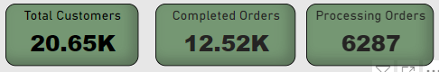

**Figure 16: Total number of customers/completed orders and processing orders**

1. **How many customers does the store have from the top profitable countries?**

The store has the largest customer base in United States with over 8000 customers, followed by France, and Mexico both with over 4000 customers each.

An infographic designer was selected to present the count of the customers using shape. The size of the image depicts the number of customers.

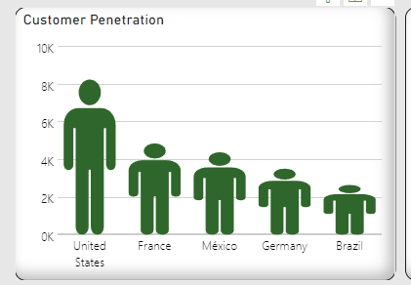

**Figure 17: Number of customers across various countries**

1. **What is the status of order made by customers?**

The status of order represents the stage of the transaction in the order cycle. There are over 12000 completed orders, and over 6000 orders are under processing.

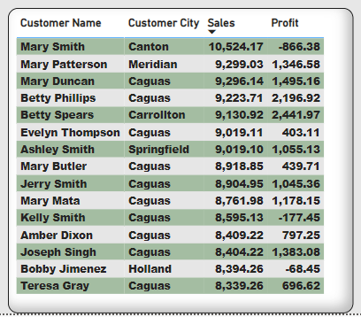

**Figure 18: Top customer summary table based on sales and profit**

**SHIPPING ANALYSIS**

1. **What is the store’s delivery risk ratio and which regions are experiencing late deliveries?**

The store has about 55% late deliveries, while about 45% of the orders were delivered on time. Western Europe has over 5500 late deliveries, while Central America has about 5000 late deliveries.

Over 36000 orders were delivered late, while over 11000 orders were delivered on time.

The pie-chart was used to display the delivery ratio to express the part to whole relationship between the 2 categorical data.

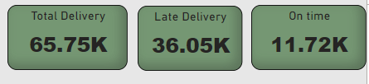

**Figure 19: Total number of deliveries/late deliveries/on time deliveries**

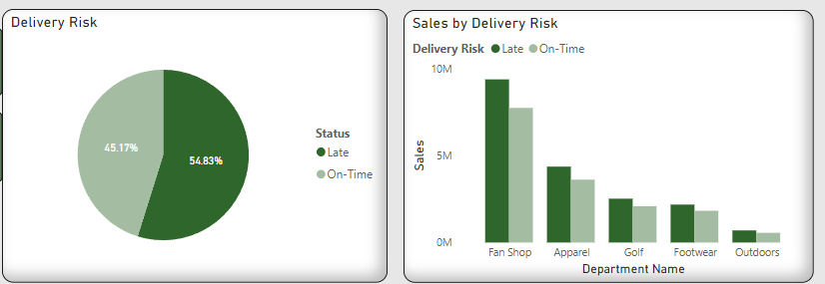

**Figure 20: Percentage of late and on-time delivery/delivery risk on product sale**

**PREDICTIVE ANALYSIS**

From analysis, a rise in discount by 21 pounds increases the sales amount by 12 pounds, the predictive analysis also shows that an increase in product price would increase the average sale of the store.

The key influencers were selected to show the top contributors to the sales growth, it assists in determining the individual factors that drives sales.

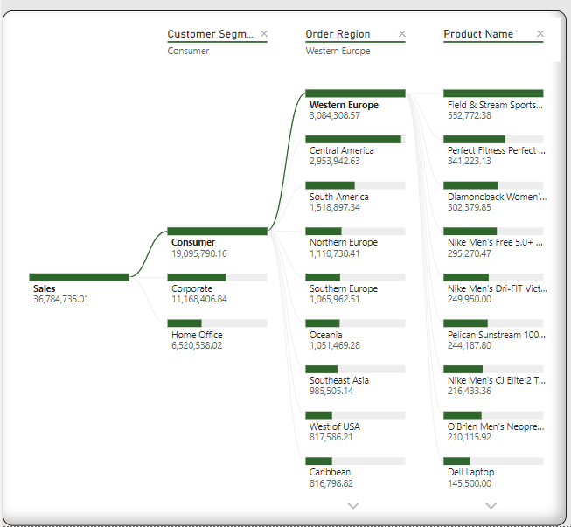

**Figure 21: Total sales across various customer segments, regions and product name**

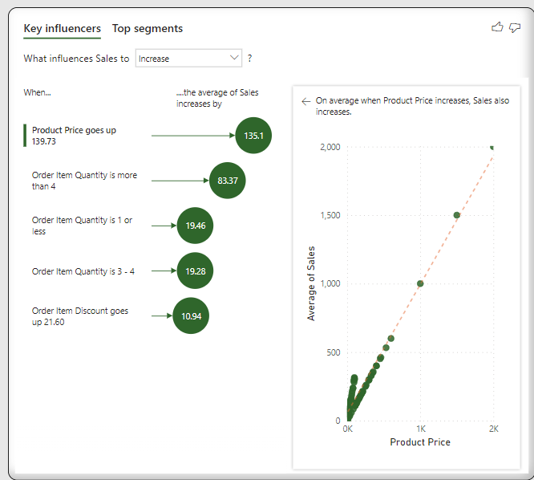

**Figure 22: key influencers on sales performance**

## Summary

* Over 36million pounds has been earned as revenue by Data Global, with an average sales value of 203 pounds. A total of 65750 orders have also been made.
* The store has made a profit of 3.97million pounds, which translates to about 10.78% in profit margin and a declining yearly growth rate
* The store has its largest market in Europe with over 10million pounds and it has its smallest market in Africa.
* Western Europe and Central America are the top performing regions
* Data Global earns its highest revenue from sale of Field and stream Sportman product
* Over 14million pounds have been paid by customers using Debit and about 10million pounds have been paid using transfer payment options.
* Fan shop is the most profitable Department, while SOLE E35 Elliptical is the least profitable product
* The store has customer base of over 20000, with its largest customer base in the United States.
* 55% of orders were delivered late while 45% were delivered on time. With Western Europe and Central America having more of the late deliveries.

## Recommendation

Pricing: There is need to review the prices of product offered for sale, the analysis revealed that some products are being offered at a price lower than the actual cost of the product. This has been resulting into loss of revenue for the store

Discount: A removal of discount from some products that are currently not profitable is being recommended as it contribute to the revenue loss experienced by the store.

Market Expansion: A more aggressive campaign should be targeted at the less performing markets such as Africa and Central America, this will boost the sales of the store.

Effective delivery system: The analysis shows the store has 55% late delivery ratio and this implies that many customers would have bad customer experience because of late delivery. A more effective delivery system should be implemented to enhance better customer experience.

Customer Penetration: The current customer base is currently low, well-tailored marketing campaigns should be developed to increase the customer base which will likely result into more sales for the store.

## Conclusion

Based to the analysis conducted, Data Global's sales growth has been very minimal, resulting in low profit. Using the "Sale by market" analysis, some regions, such as Africa, appear to require more attention, and the marketing team appears to be operating with lower attributes and discounts on their various products. The company should pay more attention to product sales prices in order to forecast which products will sell more in different countries and when to include discounts without incurring significant losses.

# ICA – Appendix: BI Design

## Data Pre-Processing or Data Cleansing

The data set is loaded into Power BI using the "Get Data" button on the home menu as the first process in this analysis. The option "Text/CSV" was chosen from the list of choices since the file type is saved in CSV format. The data was loaded into power Bi successfully without errors and the “Transform data” menu was used in pre-processing steps such as changing type, removing columns, merging columns and so on. Below are the list and details of steps carried out in cleansing the data.

* Promoting Headers:

The first row of the data set was used as header using “Use First Row as Header” on the home menu of the power query.

**Figure 1: Result after promoting headers**

* Removing Columns:

The unwanted columns were deleted by pressing the control button and selecting each unwanted columns, right click and select the “remove columns “option. Alternatively, you can click on the “Choose column option on the home tab of and deselect the unwanted columns.

The Columns deleted are Customer Country, Customer Email, Customer state, Customer Street, Customer Zipcode, Latitude, Longitude, Order Item Id, Order Zipcode, Product Description, Product image, Product Status, product Category Id, Product Card Id, Order Item, Cardprod Id. These columns were deleted because they are irrelevant to answering the BI questions for this analysis. Some other columns such as order date (DateOrder).2 and shipping date (DateOrder) timestamp were removed later during the pre-processing step.

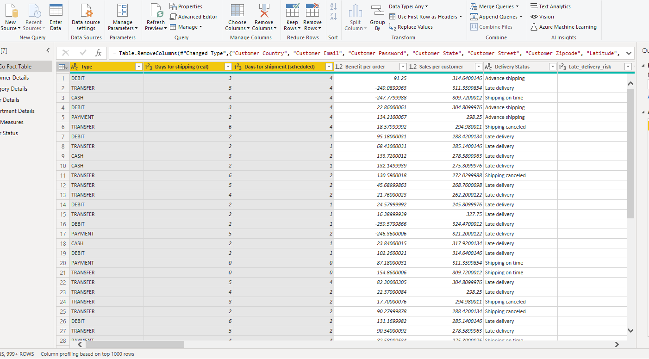

**Figure 2: Result after renaming columns**

* Merged Columns:

The customer first name and customer last name were merged using the “Merge Column” option. After selecting the columns, “space” was selected as the separator to separate the first and last name after creating the new column. This column was merged in other to have the Customer name in a single column.

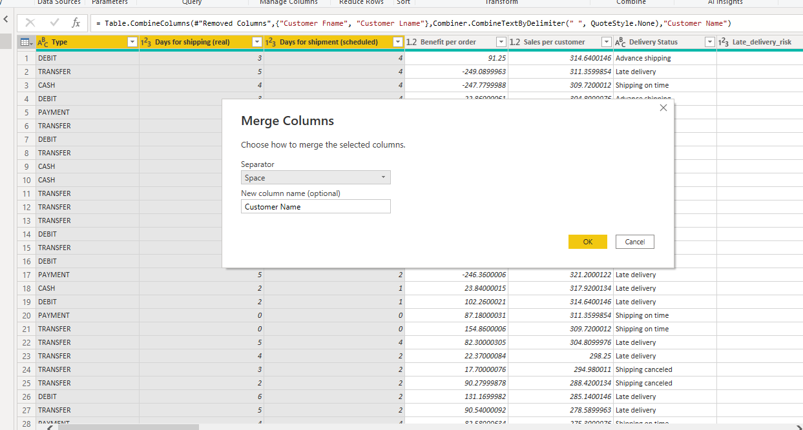

**Figure 3: Table showing how to merge columns**

**Figure 4: Tables showing selected columns to be merged**

**Figure 5: Result showing the table after the columns have been merged**

* Splitting columns:

The fist column that was split was the order date(Dateorders) column because it contains a timestamp was not needed in this analysis. The first step was separating the timestamp from the date using the “Split Column by Delimiter “option on the dropdown and then deleting the column created for timestep after splitting.

The second column that was split was the shipping date(Dateorders) column. The same step used for the order date(Dateorders) were repeated for to this column.

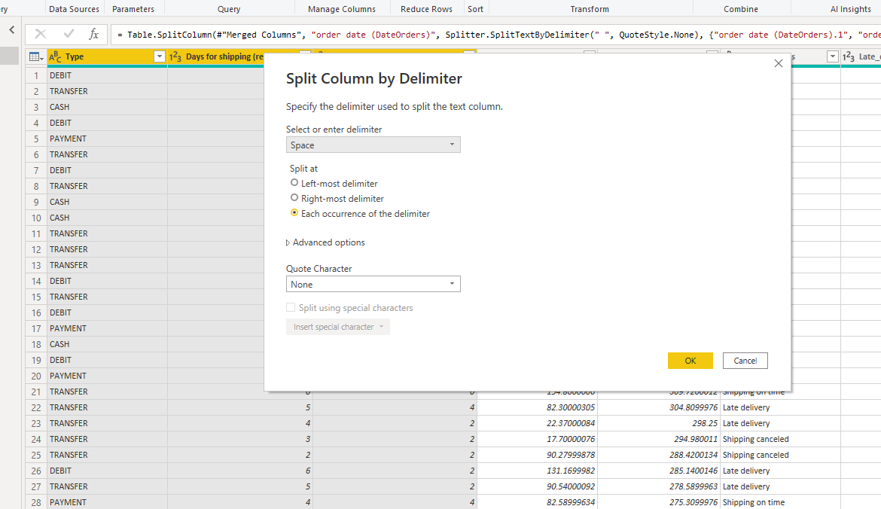

**Figure 6: Splitting column by delimiter**

* Resolving Error on Order Date column

After splitting the order date(Dateorders) column, the data type was changed to a date format. This resulted to an error in the column. In other to fix this error, the column was replaced to its initial text format.

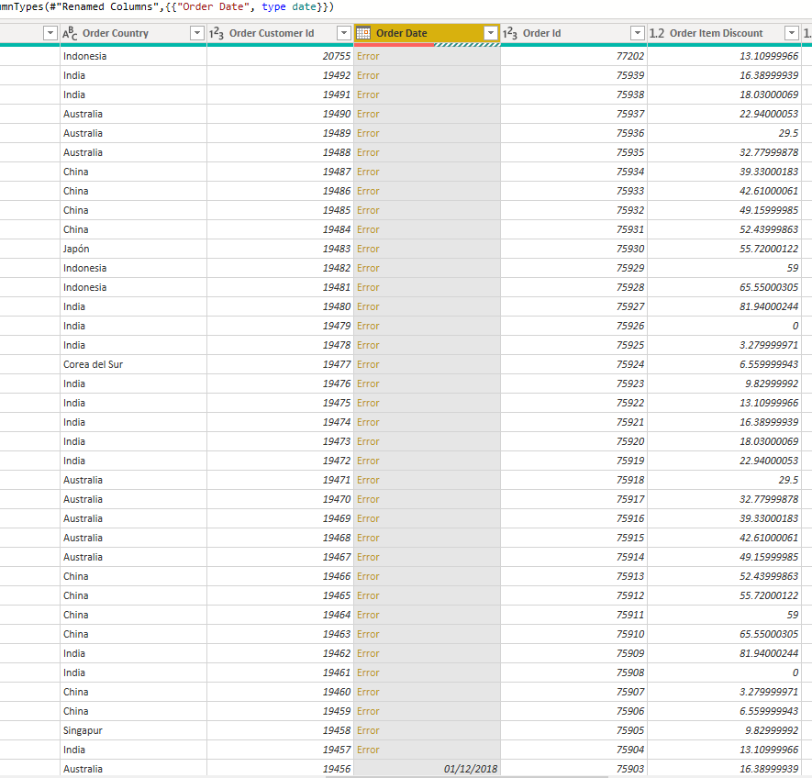

**Figure 7: Resolving date errors**

* Changing Data Type

Due to the error that occurred while changing the type of the order date, the “Change Type with Locale” option was used in changing the

Type to a date format. This same process was used when changing the shipping date(Dateorders) column.

Also, the Days of shipping(real) and Days of shipment(scheduled) column were changed to numbers from text.

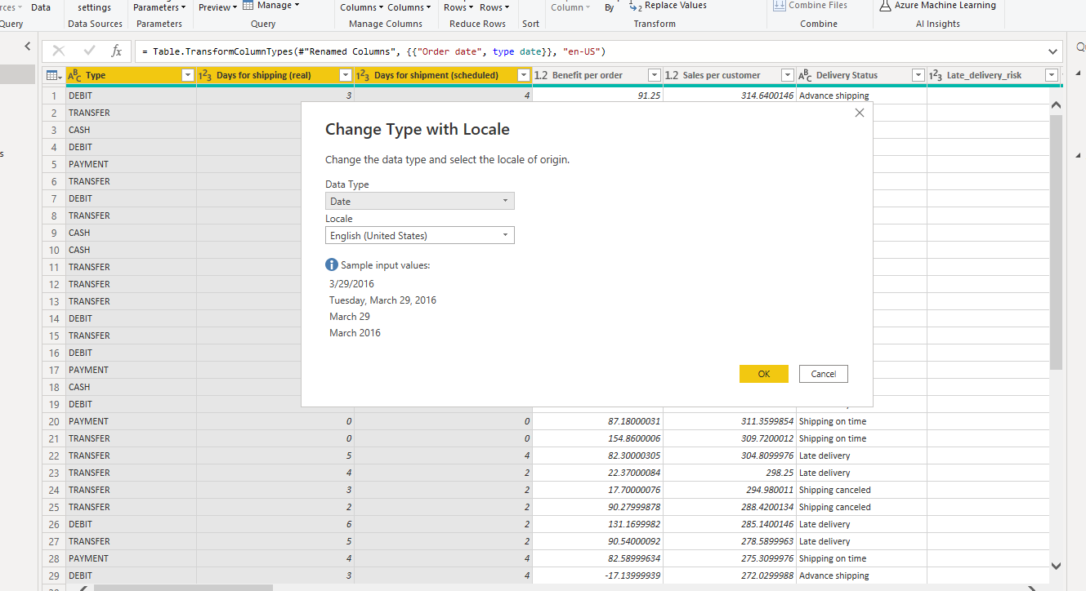

**Figure 8: Changing type using “Change Type Locale”**

**Figure 9: Table after the data type has been changed**

* Renaming Columns:

The “order date(Datorders)” column was changed to “Order Date”,

The “shipping date(Datorders)” column was change to Shipping Date

The Type column was changed to Payment Type to easily remember the type of data contained in the column.

* Creating custom column

To have a thorough analysis of the dataset, custom columns were created to establish some factors that affect the Global sales analysis in other to convey a story behind the data. The columns created are Delivery Status and Order status. The delivery status was created to show the identify if a shipping is late or on time, while the order status was created and renamed to represent the various order status.

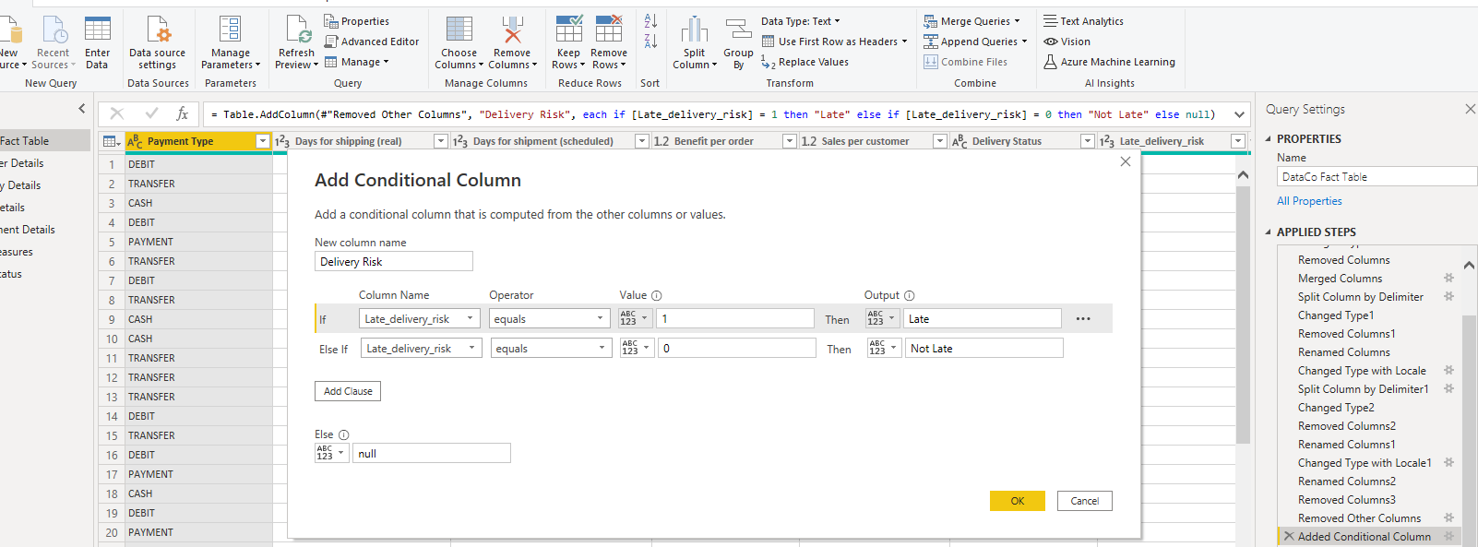

**Figure 10: Creating custom column using the “add conditional column” option**

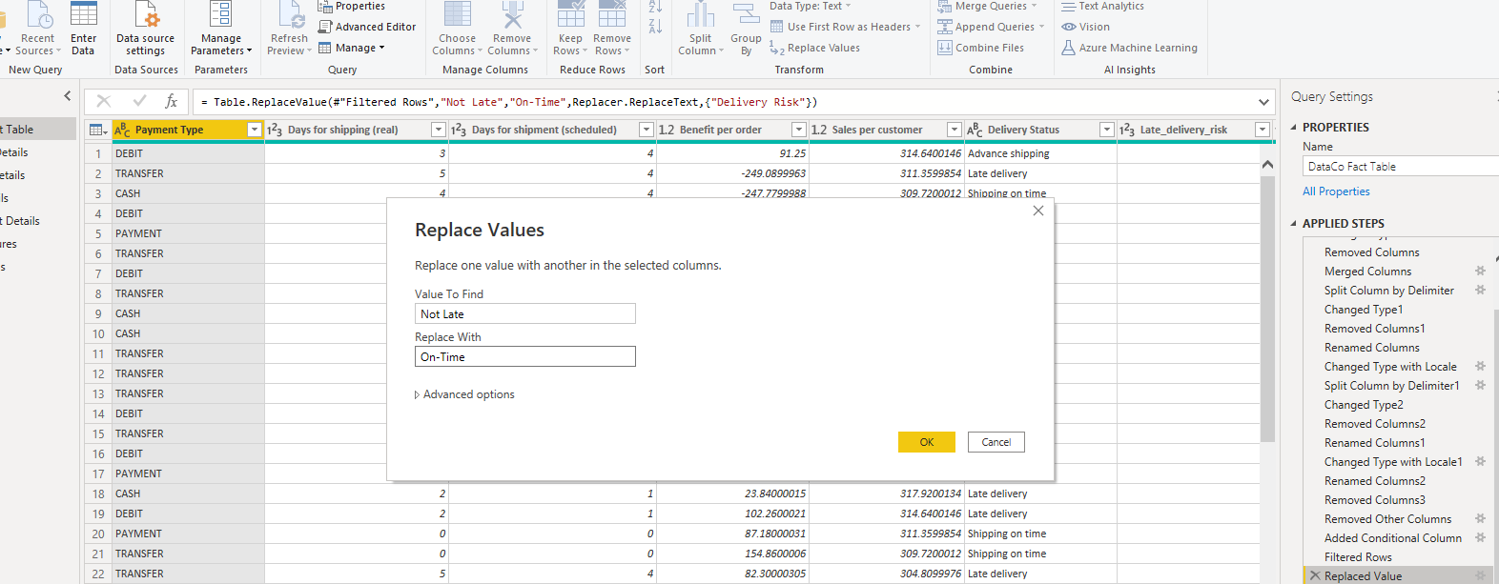

**Figure 11: Replacing values for Delivery status Column**

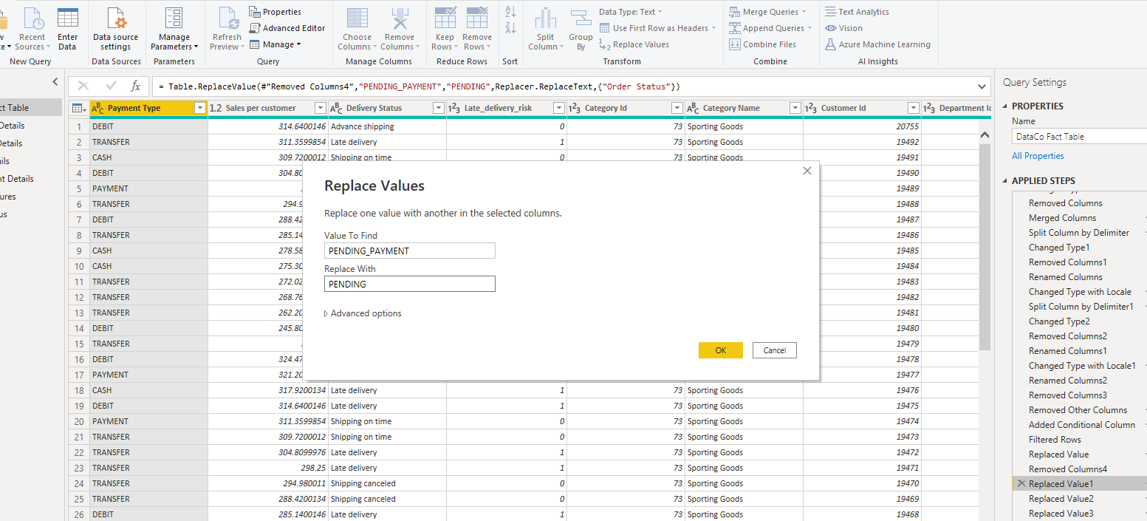

**Figure 12: Replacing values for Order status column**

## BI Data Modelling

The process of analysing and storing data in a form that facilitates easy data flow is known as data modelling (Microsoft, 2022). It allows businesses distinguish between the various types of data that are gathered in their industry and determine how to use that data to build structures and reach wise business judgements.

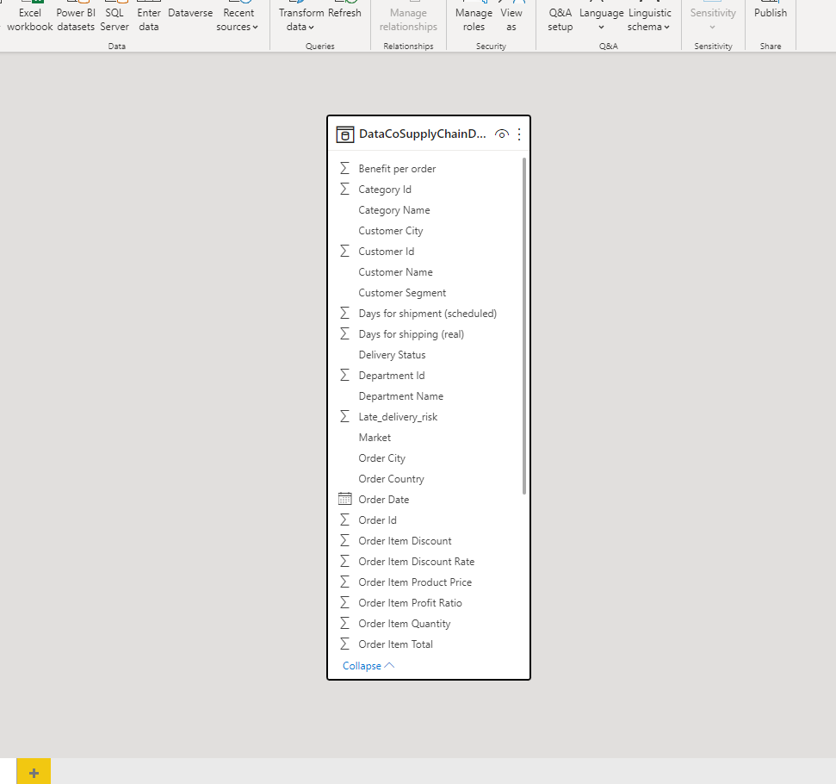

**Figure 13: Data model before creating dimension tables**

The first step was duplicating the DataCo table 5 times as the intent is to have 5 dimension tables and a fact table. After the duplicate tables have been created, we then proceed to creating our first table which is the **Customer Details Table**. This table was created to house the vital details about the customer as it would be used in answering Bi questions and caring out analysis on the customer. The column in this table includes the Customer name, Customer City, Customer segment and a Customer Id that will link this dimension table to the fact table and serve as a relationship. After this table was created other columns that are irrelevant to this table were deleted and the table was filtered to remove all duplicates to avoid data redundancy.

The next table created was the **Category Details Table**, it contains the Category name and a category Id that will serve as the link to the fact table.It will be used in analysing the category of products and sales. The same process carried out in creating the customer details table was implemented in creating this table.

The **Order Details Table** was created, it contains rows and column with geographical information of the orders and has an Order Id that serves as a relationship between the fact and the dimension table. This table will be used to analyse and answer business questions related to the performance of the business based on the geographical locations of the business.

The **Department Details Table** contains the department name and the department Id which will serve as the link relationship table.

**Figure 14: Data model after creating dimension tables**

After the dimension tables have been created, the unwanted column is deleted leaving the unique ID of each table in DataCo table. This ID’s will be used to in linking the dimension tables to the DataCo Table that will then serve as our Fact table.

Once all tables are linked the ID, to form relationships a star schema Model was created.

A Star schema model is a model that facilitates the grouping of data into facts and dimension tables based on the links and attributes between data and helps to construct a system that decreases redundancy and improves the data flow of the entire Data warehouse.

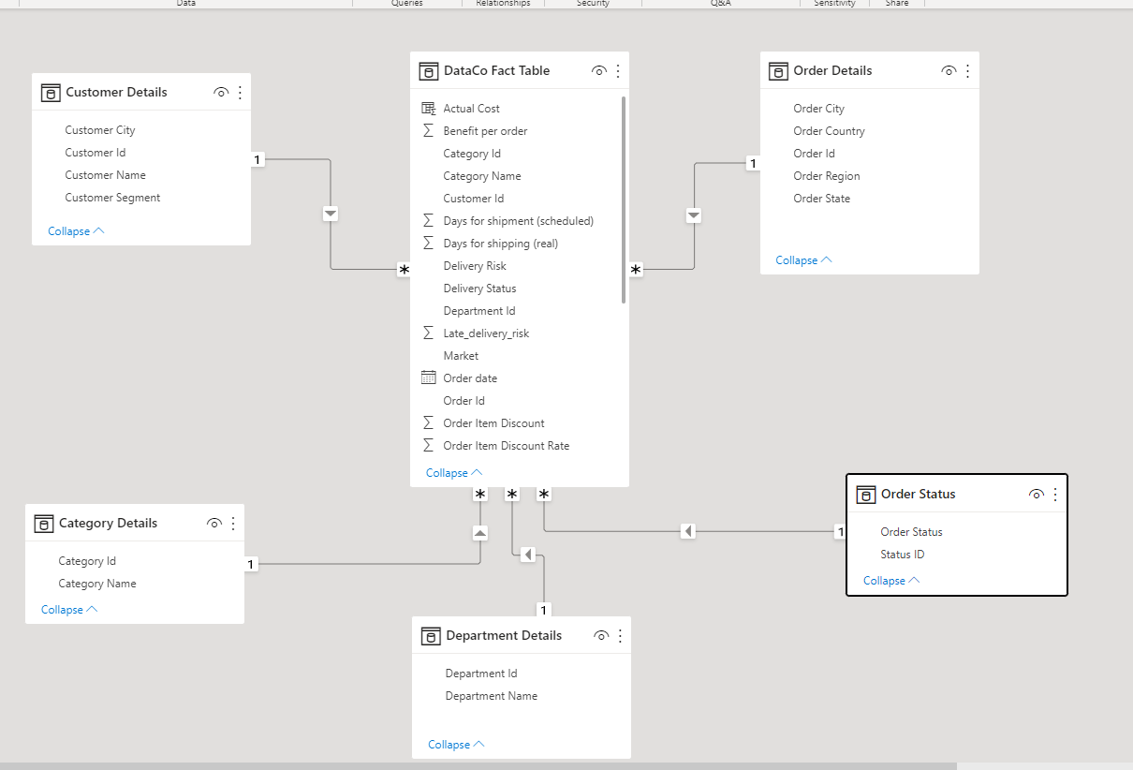

**Figure 15: Star Schema Model after creating relationships.**

# DAX and M Language

**Using DAX in creating measures and columns**

In this analysis DAX was implemented in creating columns and measures to further assist in answering the BI questions.

**Creating Measure to Show Key Indices**

* Total sales

A measure was created to calculate the total sales by summing up the sales column

**Total Sales = SUM('DataCo Fact Table'[Sales])**

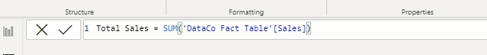

* Profit

A profit measure was created so it can be used in calculating the profit margin. This was done by summing up the Order per order column

**Profit = SUM('DataCo Fact Table'[Order Profit Per Order]**

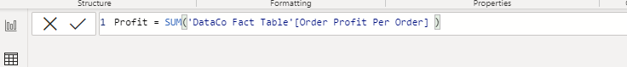

The percentage profit margin was created by using the DIVIDE function to divide the Profit sum by the total sales.

**% Profit Margin = DIVIDE('Data Measures'[Profit], 'Data Measures'[Total Sales],0)**

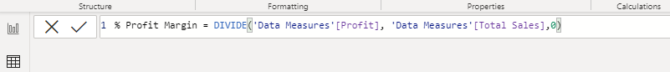

* **Customer**

The total customer measure was created by using the CALCULATE function, this function counts the rows in in the customer details column and then sums it up.

**Total Customer = CALCULATE(COUNTROWS('Customer Details'))**

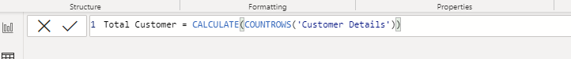

**Creating a table for the Year-on-Year growth rate**

A table was created to compute the summarised performance of the store’s year-on-year growth rate. The variable “Profit Growth” applies the use of a GROUPBY function used to perform aggregations over intermediate results from DAX table expressions. The sum of profit earned each year is aggregated by the **GROUPBY** function. The **SUMX(CURRENTGROUP()** function contains all the rows in the Sum operation computed over an iteration of the “Order Profit Per Order” column



**Profit Growth = GROUPBY('DataCo Fact Table','DataCo Fact Table'[Order date].[Year], "YearlyProfit", SUMX(CURRENTGROUP(),'DataCo Fact Table'[Order Profit Per Order]))**

**Computing the yearly growth rate**

**currentprofit: which denotes the YearlyProfit from the created Profit Growth table for the current year**

**currentyear: represent the year from the Profit Growth table**

**previousProfit: The CALCULATE function evaluates the expression by filtering the value of YearlyProfit in groupby function. It then that computes the increase or decrease in current year’s profit compared to the previous year. The IF logical conditional function checks that PreviousProfit is not blank to avoid a divide by zero error**



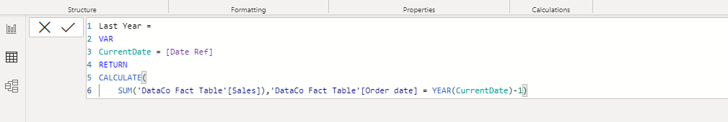

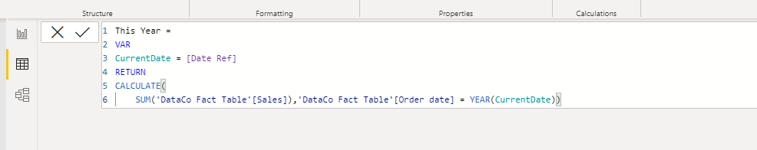

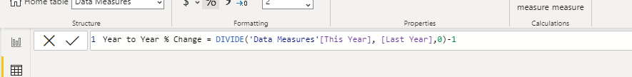

**%Profit = VAR currentProfit = 'Profit Growth'[YearlyProfit]**

**VAR currentyear = 'Profit Growth'[Year]**

**VAR previousProfit =**

**CALCULATE (**

**SELECTEDVALUE('Profit Growth'[YearlyProfit]),**

**ALL('Profit Growth'),**

**'Profit Growth'[Year] = currentyear -1**

**)**

**RETURN IF (**

**NOT ISBLANK (previousProfit),**

**DIVIDE(currentProfit,previousProfit) -1,0)**

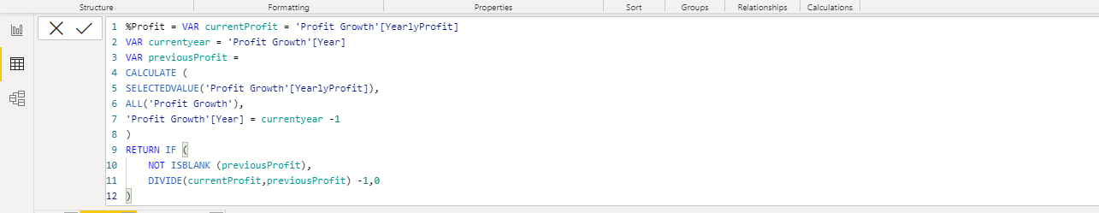





# Dashboard

### Home Page/ Overview

This dashboard displays a comprehensive analysis of the business project. It has a homepage that allows you to navigate through the dashboard's pages. Other pages on the dashboard include sales analysis, profit analysis, customer analysis, shipping analysis, and predictive analysis. Each of these pages is intended to answer business questions and provide in-depth analysis of the overall business process.

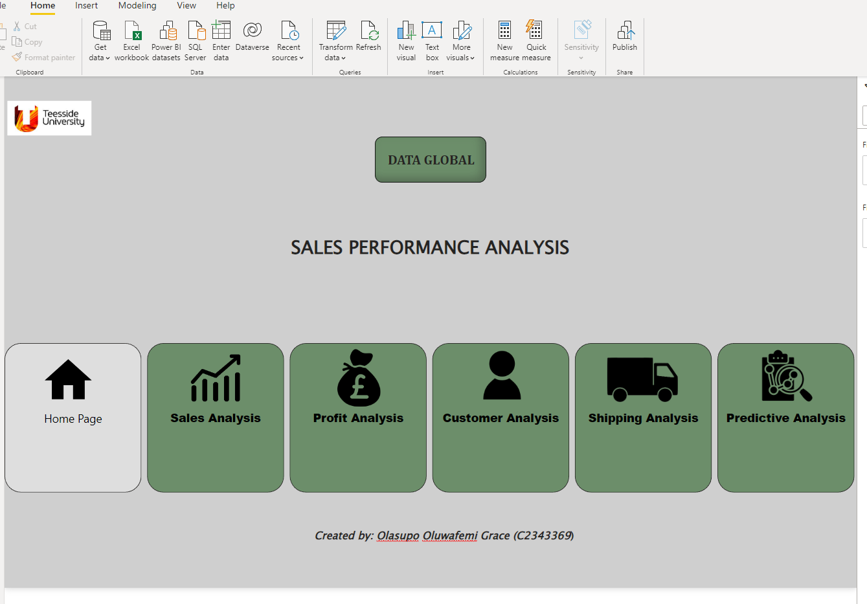

**Figure 16: Dashboard Home page**

### Sales Analysis Dashboard

The Sales Analysis dashboard has the key performance indicators (KPIs) that tracks the business overall sales, average sales, and total orders. The dashboard is made up of several graphs that are used to provide information on the business overall sales performance. It has different slicers that may be used to explore the dashboard in more detail.

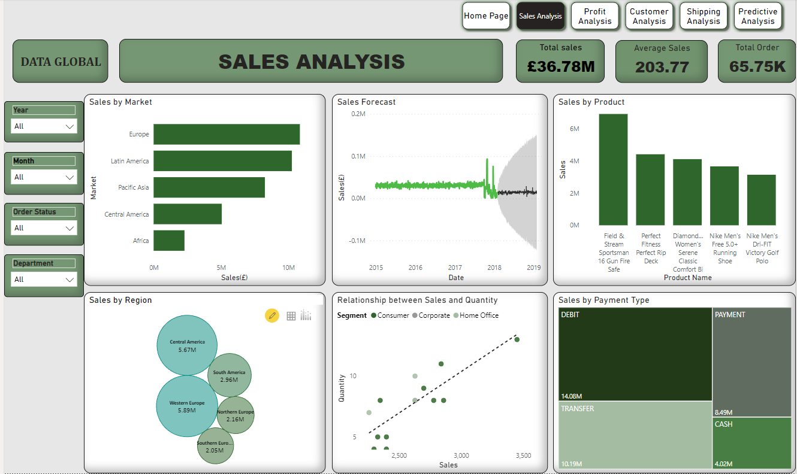

**Figure 17: Sales analysis dashboard**

### Profit Analysis Dashboard

The Profit Analysis Dashboard contains visuals that measures the profit and profit margin of the business which is very crucial in measuring the growth of the business. It includes charts that shows the profitable products, the least performing products, and the overall profit on sales.

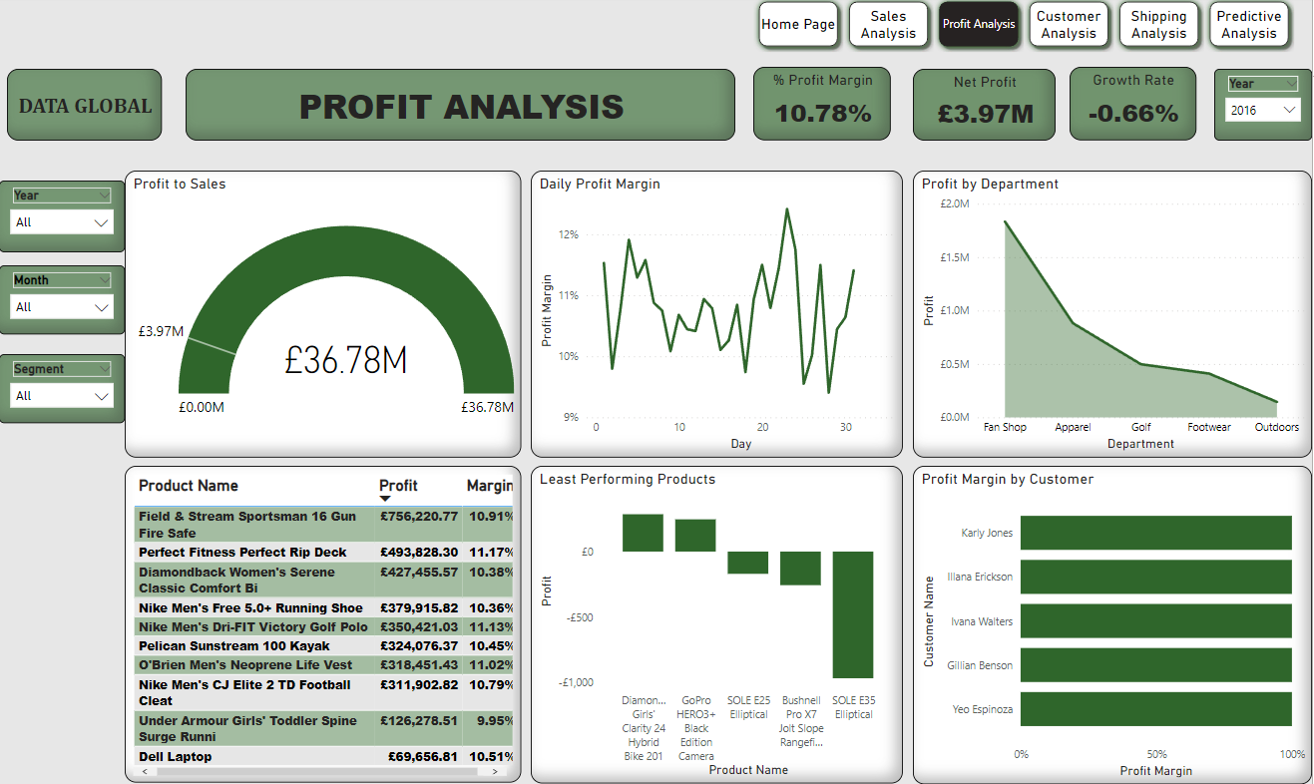

**Figure 18: Profit analysis dashboard**

### Customer Analysis Dashboard

The Customer Analysis dashboard enables business owners to view the regions and countries where customers place the most orders as well as an analysis of the sales and profit of the top customers. Additionally, it displays the business's Key Performance Indicators (KPIs) for total clients, finished orders, and order processing.

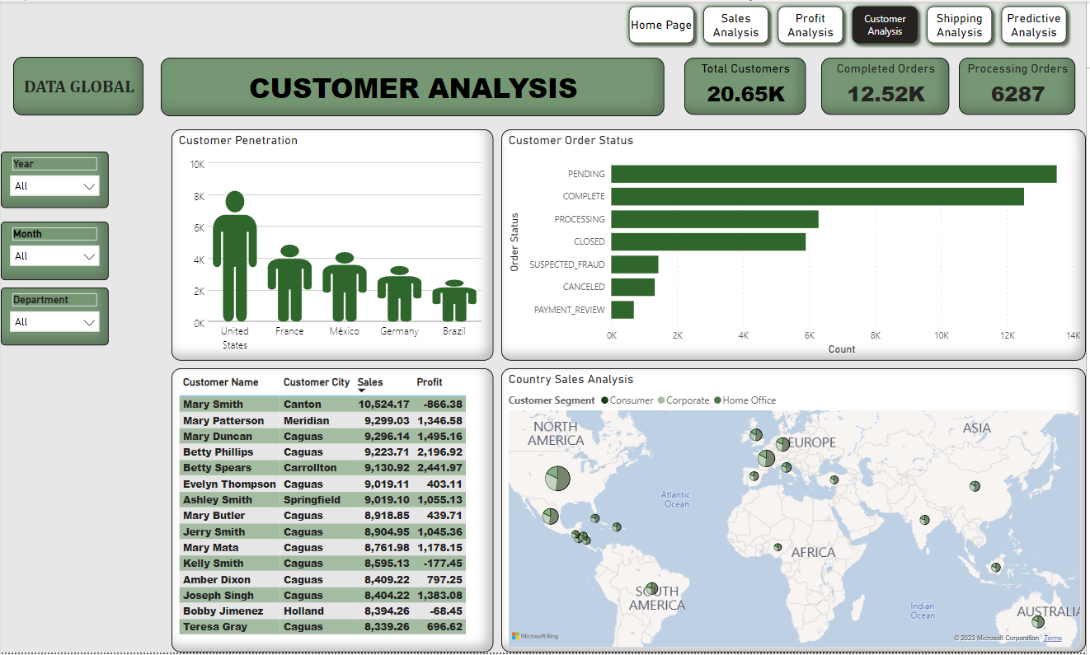

**Figure 19: Customer analysis dashboard**

### Shipping Analysis Dashboard

The shipping analysis dashboard measures the business’s overall delivery, late delivery, and on-time delivery using the card visuals to represent this KPIs. It displays the total shipping modes, the best-performing category by their shipping modes, and the delivery risk percentage ratio.

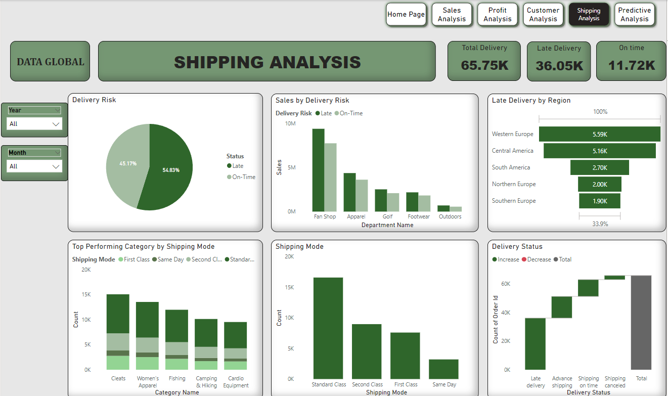

**Figure 20: Shipping analysis dashboard**

### Predictive Analysis Dashboard

The predictive analysis page utilizes the use of artificial intelligence to highlight key factors that influence the sales in the store. It makes recommendations by learning patterns from the existing data. It also has a tree decomposition visual that shows data from different dimensions and can be used in root cause analysis.

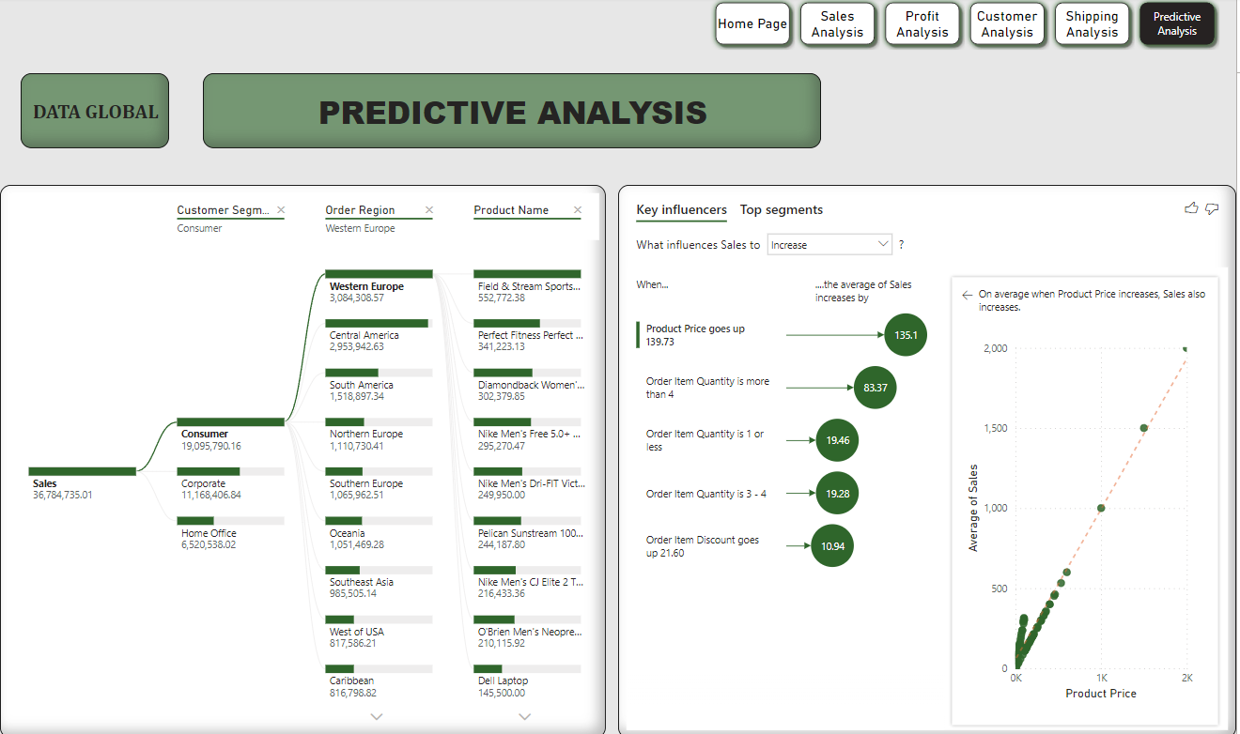

**Figure 21: Predictive analysis dashboard**

**Self-Assessment**

|  |  |  |
| --- | --- | --- |
| **Report Section** | **Description** | **Grade your work from 0 to 100** |
| Report Structure | The report is well-written, and it contains all the relevant sections | 85 |
| Data Pre-processing and Data Modelling | Many pre-processing steps have been applied. The data model is well-structured | 85 |
| Dax and M language | Both DAX and M Language have been **extensively** used in the report | 85 |
| Dashboard Design | The dashboard contains a variety of charts, including advanced ones not covered in the module. | 85 |
| **Average** |  | **Add below the average of the four cells above:**  **85** |

# Reference

Tiwari, S. (2019) *Dataco Smart Supply Chain for Big Data Analysis*, *Kaggle*. Available at: https://www.kaggle.com/datasets/shashwatwork/dataco-smart-supply-chain-for-big-data-analysis (Accessed: December 31, 2022).

Team, P.B.I. (no date) *What is data modelling? | Microsoft Power BI*. Microsoft. Available at: https://powerbi.microsoft.com/en-za/what-is-data-modeling/ (Accessed: December 27, 2022).

Contributor, T.T. (2012) *What is dimension table?: Definition from TechTarget*, *Data Management*. TechTarget. Available at: https://www.techtarget.com/searchdatamanagement/definition/dimension-table (Accessed: December 27, 2022).

DougKlopfenstein (no date) *Table.replacevalue - powerquery m*, *PowerQuery M | Microsoft Learn*. Available at: https://learn.microsoft.com/en-us/powerquery-m/table-replacevalue (Accessed: December 27, 2022).